|  |  |
| --- | --- |
| *Pacific Gas and Electric Company* | |
| Patch 7.6.21 Installation Guide | |
|  |  |
|  |  |
| Project | ED AM/GIS |
|  |  |
| Prepared by | Ashish Narasimham, Bhaskar Singh |
| Date | 11/26/2013 |
| Version | 1.0 |
| Version Type | Final |

|  |  |  |  |
| --- | --- | --- | --- |
| Revision History | | | |
| Document # | Date | Author | Summary of Changes |
| 1.0 |  | Ashish Narasimham, Bhaskar Singh | Initial Document Creation |

# Introduction

## Purpose

This document is intended to detail the implementation and configuration steps required to implement Patch 7.6.21 Installation Guide. This document describes the various configuration aspects required to complete any manual or automatic patch associated with this release. Each section in this document contains the steps required to patch the system in production.

## Terms Used

|  |  |
| --- | --- |
| OOTB | Out of the box. Unmodified from the commercial version. |
| TFS | Team Foundation Server |

## ­External Documents

Referenced are any external configuration documents or exports. These are documents that contain more detailed information about configuring a system or documents that can be loaded into an application to perform the configuration detailed in this document.

1. Batch script
   1. Batch script location: \\sfetgis-nas01\sfgispoc_data\ApplicationDevelopment\IBM_Delivery\Production Release 11.20\Batch
   2. Name: 7_6_21_Release.bat
2. ArcFM XMLs
   1. XMLs location: \\sfetgis-nas01\sfgispoc_data\ApplicationDevelopment\IBM_Delivery\Production Release 11.20
   2. Name: Substation_ArcFMProperties_11_14.xml
   3. Name: Substation_ArcFMModelNames_11_18.xml
   4. Name: arcfm_properties_sublink.xml

## List Of Fixes

Below is the list of change requests detailing all fixes for the data model for this release:

|  |  |  |  |
| --- | --- | --- | --- |
| **Item Number** | | **Title** | **Work Item Type** |
| [10828](http://edappgistfsprd1:8080/tfs/ElectricDistCollection/EDAMGIS/_workitems#_a=edit&id=10828) | | Data Model 7.6.21 | Change Request |
| [9654](http://edappgistfsprd1:8080/tfs/ElectricDistCollection/EDAMGIS/_workitems#_a=edit&id=9654) | PAR 25303: Add Value To SUB Rated Amps | Change Request |
| [9782](http://edappgistfsprd1:8080/tfs/ElectricDistCollection/EDAMGIS/_workitems#_a=edit&id=9782) | Modify Fields for Feature SUBExtraWinding. | Change Request |
| [9783](http://edappgistfsprd1:8080/tfs/ElectricDistCollection/EDAMGIS/_workitems#_a=edit&id=9783) | Assign Domain To Field In SUBElectricStitchPoint | Change Request |
| [10126](http://edappgistfsprd1:8080/tfs/ElectricDistCollection/EDAMGIS/_workitems#_a=edit&id=10126) | Missing AU on Substation Transformer Unit RelationshipClass | Change Request |
| [10127](http://edappgistfsprd1:8080/tfs/ElectricDistCollection/EDAMGIS/_workitems#_a=edit&id=10127) | Add LOCALOFFICEID Field To Feature Classes | Change Request |
| [10335](http://edappgistfsprd1:8080/tfs/ElectricDistCollection/EDAMGIS/_workitems#_a=edit&id=10335) | DA Issue: SUBGenerator Feature Class Has SUBTYPECD But No Subtypes | Change Request |
| [10336](http://edappgistfsprd1:8080/tfs/ElectricDistCollection/EDAMGIS/_workitems#_a=edit&id=10336) | Change Field to TEXT 50 for SubstationID on SUBBusbar , SUBOHConductor, SubUGConductor, SUBStationBoundary | Change Request |
| [10372](http://edappgistfsprd1:8080/tfs/ElectricDistCollection/EDAMGIS/_workitems#_a=edit&id=10372) | PAR: 34156 - Add value to the following domain: "SUB Boost/Buck Percent" | Change Request |
| [10373](http://edappgistfsprd1:8080/tfs/ElectricDistCollection/EDAMGIS/_workitems#_a=edit&id=10373) | PAR: 34526 - Add value to the following domain: "SUB Interrupting Current Rating" | Change Request |
| [10543](http://edappgistfsprd1:8080/tfs/ElectricDistCollection/EDAMGIS/_workitems#_a=edit&id=10543) | Substation Annotation Justification Modifications | Change Request |
| [10544](http://edappgistfsprd1:8080/tfs/ElectricDistCollection/EDAMGIS/_workitems#_a=edit&id=10544) | SUBSwitchAnno / Current subclass Modification | Change Request |
| [10714](http://edappgistfsprd1:8080/tfs/ElectricDistCollection/EDAMGIS/_workitems#_a=edit&id=10714) | Add "NormalPosition" field to switchable substation devices | Change Request |
| [10716](http://edappgistfsprd1:8080/tfs/ElectricDistCollection/EDAMGIS/_workitems#_a=edit&id=10716) | Apply ArcFM properties to meet substation requirements | Change Request |
| [10821](http://edappgistfsprd1:8080/tfs/ElectricDistCollection/EDAMGIS/_workitems#_a=edit&id=10821) | Set "Phase Designation" domain for SUBTransformerBank feature class | Change Request |
| [10869](http://edappgistfsprd1:8080/tfs/ElectricDistCollection/EDAMGIS/_workitems#_a=edit&id=10869) | DA Issue: SUBLink Feature Class Has SUBTYPECD But No Subtypes | Change Request |

## Summary of Steps to Complete Patch

These are the high-level steps to complete the installation and configuration of the data model patch. Use this table as a guide for completing the installation. Links are provided that can lead either within the document for detailed explanations or to external sites such as Sharepoint.

|  |  |  |  |
| --- | --- | --- | --- |
|  | **Step Name** | **Description** | **CR (if applicable)** |
|  | Run Batch Script | Batch script to apply a majority of the data model changes | Multiple |
|  | Open a Database Connection | Open a database connection in ArcCatalog | - |
|  | Define Subtype on SUBGenerator | No subtypes exist on SUBGenerator | [10335](http://edappgistfsprd1:8080/tfs/ElectricDistCollection/EDAMGIS/_workitems#_a=edit&id=10335) |
|  | Define Subtype on SUBLink | No subtypes exist on SUBLink | [10869](http://edappgistfsprd1:8080/tfs/ElectricDistCollection/EDAMGIS/_workitems#_a=edit&id=10869) |
|  | Substation Annotation Justification Modifications | Modify substation annotation properties | [10543](http://edappgistfsprd1:8080/tfs/ElectricDistCollection/EDAMGIS/_workitems#_a=edit&id=10543) |
|  | SUBSwitchAnno / Current subclass Modification | Uncheck coded description value box | [10544](http://edappgistfsprd1:8080/tfs/ElectricDistCollection/EDAMGIS/_workitems#_a=edit&id=10544) |
|  | Apply Change To Assign Domain To SUBElectricStitchPoint | Change a field so that we can assign a domain to SUBElectricStitchPoint | [9783](http://edappgistfsprd1:8080/tfs/ElectricDistCollection/EDAMGIS/_workitems#_a=edit&id=9783) |
|  | Drop/Re-create Fields For SUBExtraWinding | HighSideVoltage and LowSideVoltage will need to be droppe and re-created | [9782](http://edappgistfsprd1:8080/tfs/ElectricDistCollection/EDAMGIS/_workitems#_a=edit&id=9782) |
|  | Re-Execute 7.6.6 Steps | Please re-execute steps from the Installation Guide for 7.6.6 | - |
|  | Apply ArcFM properties to meet substation requirements | Import ArcFM Properties XML | [10716](http://edappgistfsprd1:8080/tfs/ElectricDistCollection/EDAMGIS/_workitems#_a=edit&id=10716) |
|  | Apply Model Name To SUBElectricStitchPoint | Apply PGE_DMSFIELD to SUBElectricStitchPoint | [9783](http://edappgistfsprd1:8080/tfs/ElectricDistCollection/EDAMGIS/_workitems#_a=edit&id=9783) |
|  | Assign AU To Substation Relationship Class | Missing AU on Substation Transformer Unit Relationship Class | [10126](http://edappgistfsprd1:8080/tfs/ElectricDistCollection/EDAMGIS/_workitems#_a=edit&id=10126) |
|  | Assign AUs and Model Names to Substation Feature Classes | Assign AUs to several feature classes to enable the NormalPosition field’s effects | [10714](http://edappgistfsprd1:8080/tfs/ElectricDistCollection/EDAMGIS/_workitems#_a=edit&id=10714) |
|  | Update Data Model Version Table | Update the data model version table to reflect this update | - |

# Run Batch Script

1. Locate the batch script (referenced in Section 1.3).
2. Copy the Batch folder (one level up) to your local hard drive.
3. Open a command prompt and CD into the Batch folder.
4. Change all database connection strings in all batch scripts to the target database.
   1. Open each file, locate the Database Connection variable, and change it to the desired sde file.
5. Run the batch script. You will be prompted to check for errors after each subscript completes. Press any key if you do not see any errors.
6. When finished, copy the full output of the batch script into a log file titled “batch.log”

# Open a Database Connection in ArcCatalog

1. Open ArcCatalog.
2. Within the Catalog Tree, expand “Database Connections” and open the active connection for this process. This is the connection that is referenced in the change request associated with this document (EDGIS<DB name in the format X#Y> )

# Define Subtype on SUBGenerator

1. In the Substation Dataset, right click the SUBGenerator feature class and select Properties.
2. Select the Subtypes tab.
3. Select SUBTYPECD for the Subtype Field dropdown
4. In the Subtypes list, enter ’1’ for the Code and ‘SUBGenerator’ for the description   
   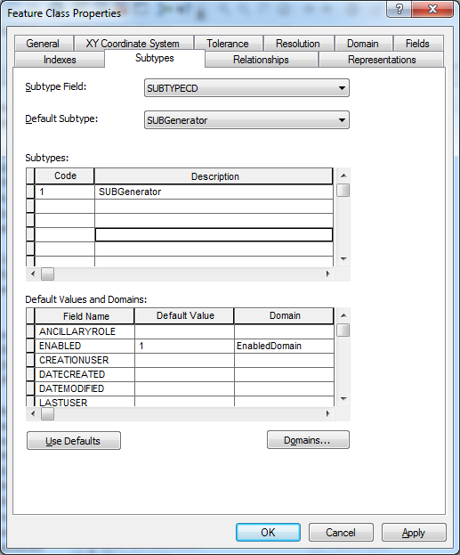

# Define Subtype on SUBLink

1. In the Substation Dataset, right click the SUBLink feature class and select Properties.
2. Select the Subtypes tab.
3. Select SUBTYPECD for the Subtype Field dropdown
4. In the Subtypes list, enter ’1’ for the Code and ‘SUBLink’ for the description 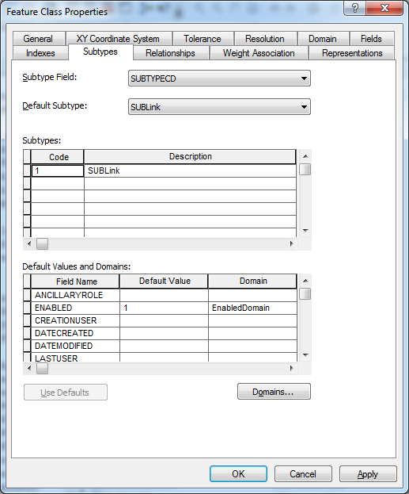

# Substation Annotation Justification Modifications

1. In the Substation dataset, right click SUBVoltageRegulatorAnno and select Properties.
2. Select the Annotation Classes tab and select the Default annotation class.
3. Select Symbol->Edit Symbol and set the horizontal alignment to “Left”  
   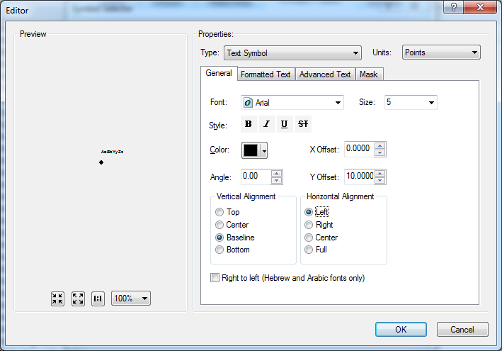
4. Select OK and OK again to apply changes.
5. Perform the above steps again for SUBStationTransformerAnno, SUBMtuAnno, and SUBPotentialTransformerAnno
6. Right click the SUBPotentialTransformerAnno feature class and select Properties.
7. Select the Annotation Classes tab and select the Phase Designation annotation class.
8. Select Symbol->Edit Symbol and set the horizontal alignment to “Left”.
9. Select OK and OK again to apply changes.

# SUBSwitchAnno / Current subclass Modification

1. In the Substation Dataset, right click the SUBSwitchAnno feature class and select Properties.
2. In the Annotation Classes tab, select the Current annotation class.
3. Select the ‘Expression’ button.
4. Uncheck the ‘Display coded value description’ checkbox  
   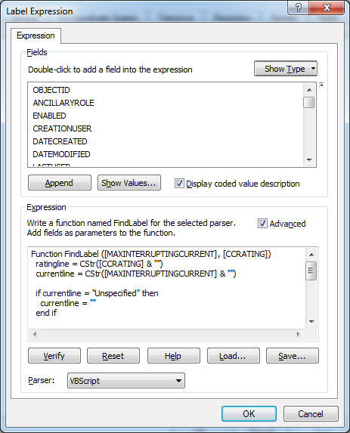

# Apply Change To Assign Domain To SUBElectricStitchPoint

1. In the Batch directory (referenced in Section 1.3), double click the 9783 folder to go into it. You should be working inside a local copy of the directory. If not, copy the 9783 folder locally.
2. Change all database connection strings in all Python files of this directory to the target SDE file.
3. Execute part1.bat via command prompt.
4. Copy the output of the commands into a log file titled “subelec.log”
5. Open ArcCatalog as EDGIS.
6. In the Substation Dataset, double click SUBElectricStitchPoint.
7. In the Fields tab, scroll to the bottom of the fields list and create a new field with the following properties:
   1. Field Name: NOMINALVOLTAGE
   2. Data Type: Float
   3. Alias: NominalVoltage
   4. Allow Null Values: Yes
   5. Default Value: <none>
   6. Precision: 5
   7. Scale: 2
8. Execute part2.bat via command prompt.
9. Copy the output of the commands into a log file titled “subelec.log”

# Drop/Re-create Fields For SUBExtraWinding

1. In the Batch directory (referenced in Section 1.3), double click the 9782 folder to go into it. You should be working inside a local copy of the directory. If not, copy the 9782 folder locally.
2. Change all database connection strings in all Python files of this directory to the target SDE file.
3. Execute part1.bat via command prompt.
4. Copy the output of the commands into a log file titled “subextra.log”
5. Open ArcCatalog as EDGIS.
6. In the Substation Dataset, double click SUBExtraWinding.
7. In the Fields tab, scroll to the bottom of the fields list and create a new field with the following properties:
   1. Field Name: HIGHSIDEVOLTAGE
   2. Data Type: Float
   3. Alias: HighSideVoltage
   4. Allow Null Values: Yes
   5. Default Value: <none>
   6. Precision: 5
   7. Scale: 2
8. Create another new field with the following properties:
   1. Field Name: TERTIARYVOLTAGE
   2. Data Type: Float
   3. Alias: TertiaryVoltage
   4. Allow Null Values: Yes
   5. Default Value: <none>
   6. Precision: 5
   7. Scale: 2
9. Execute part2.bat via command prompt.

Copy the output of the commands into a log file titled “subextra.log”

# Re-Execute 7.6.6 Steps

1. Please re-execute sections 4.9 (Subpotentialtransformeranno), 4.11 (Substationtransformeranno), and section 4.14 (Subvoltageregulatoranno) of the following document. Be sure to do any bolding/un-bolding **before** changing the text size, because bolding changes the text size.

* 1. 

# Apply ArcFM properties to meet substation requirements

1. Open the location referenced in Section 1.3 for ArcFM XMLs.
2. Copy both files to your local hard drive.
3. Right click the database connection and select ArcFM XML Import.
4. Select the ‘Overwrite’ option  
   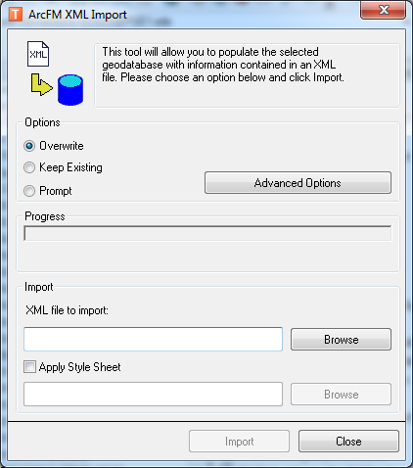
5. Browse to one of the XML files and select ‘Import’.
6. When prompted to import another file, click ‘Yes’.  
   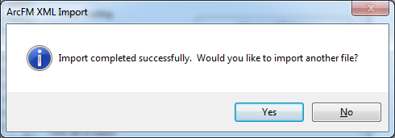
7. Browse to the other of the XML files and select ‘Import’.

# Apply Model Name To SUBElectricStitchPoint

1. Navigate into the Substation Dataset
2. Right click the SUBElectricStitchPoint feature class and select ArcFM Properties Manager. 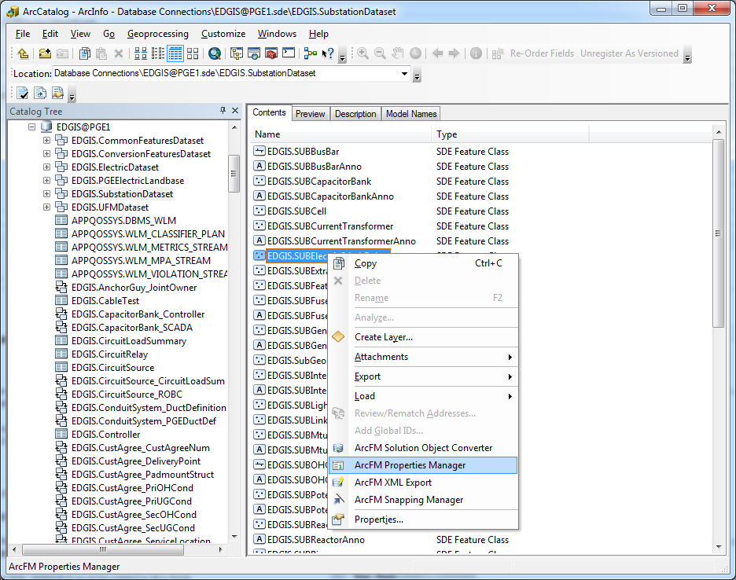
3. Select the Field Model Names tab and locate NominalVoltage. Select it.
4. In the bottom half of the window, ensure that ‘PGE ED Field Model Name’ is selected for the Model Name Domain dropdown.
5. Double click PGE_DMSFIELD on the left hand side box. It should appear inside the right hand side box.
6. Select OK to apply changes.

# Assign AU To Substation Relationship Class

1. Open ArcCatalog
2. Right-Click the EDGIS.SUBStationXFR_SUBStationXFRUnit relationship class
3. Select ArcFM Properties Manager
4. For "On Relationship Created" select the "PGE Substation Relationship LabelText AU" in the dropdown
5. For "On Relationship Deleted" select the "PGE Substation Relationship LabelText AU" in the dropdown
6. Click OK

Close ArcCatalog

# Assign AUs and Model Names to Substation Feature Classes

1. In the Substation dataset, right click the SUBSwitch feature class and select ArcFM Properties Manager.
2. Select the Object Info tab.
3. Select the box to the right of “On Feature Create”, select the dropdown, and select “<Multiple>”. A dialog should open up.

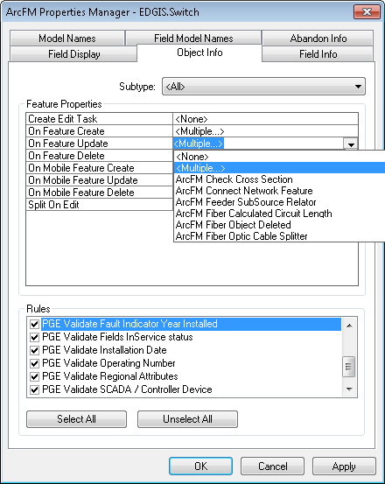

1. Select the “PGE Set Normal Position AU” from the left-hand list and select the arrow pointing right to move it to the list on the right side.  
   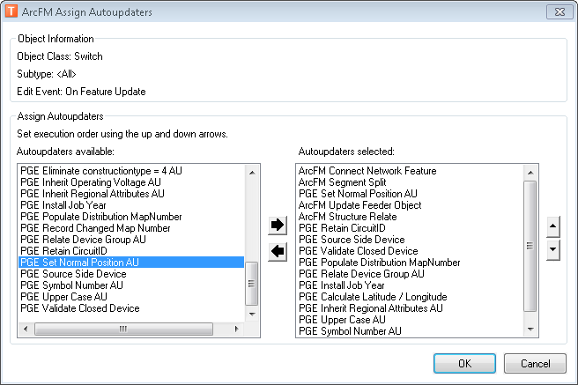
2. Select OK.­
3. Select the box to the right of “On Feature Update” that says “<Multiple>”, select the dropdown, and select “<Multiple>”. A dialog should open up.
4. Select the “PGE Set Normal Position AU” from the left-hand list and select the arrow pointing right to move it to the list on the right side.
5. Select OK.
6. Select the Field Model Names tab, scroll down to the NORMALPOSITION field, and select it.
7. Ensure that PGE ED Field Model Name is selected in the dropdown in the bottom half of the screen.
8. In the left hand side box, double click the PGE_COMBONORMALPOSITION model name to send it to the right hand side box for the field.
9. Select OK.
10. Repeat steps 1-12 for SUBFuse and SUBInterruptingDevice.
11. Right click the SDE connection and select ArcFM XML Import.
12. Select the Overwrite option.
13. Browse to the “arcfm_properties_sublink.xml” XML in the ArcFM XMLs location from section 1.3 and select that XML to import.
14. Select Import to import.

# Update Data Model Version Table

**Database Configuration:**

1. Open SQL Plus.
2. Log in using the same server and user as was used in section 2.  
     
   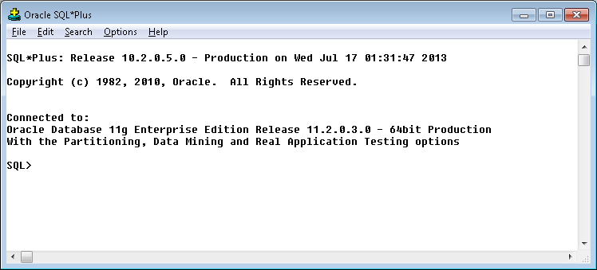
3. Run the SQL below:

update pgedatamodelversion set currentidc='N' where currentidc='Y';

insert into pgedatamodelversion (OBJECTID, CURRENTIDC, DATEAPPLIED, APPLIEDBYPERSONNAME, MODELVERSION) values (**46**,'Y',sysdate,'**<INSERT TEAM MEMBER DONE BY>**','**7.6.21** GOLD **CR10828**');

commit;

# Known Issues

<Please List any other issues encountered here while following the document>